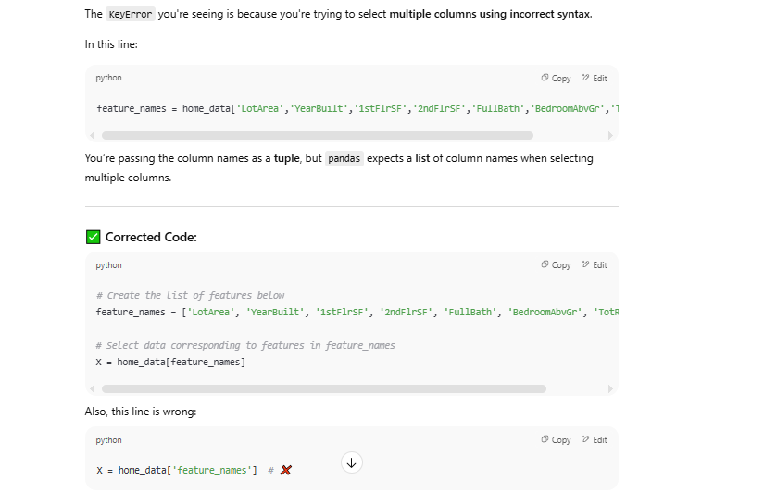
KeyError Traceback (most recent call last)
/usr/local/lib/python3.11/dist-packages/pandas/core/indexes/base.py in get_loc(self, key)
3804 try:
-> 3805 return self._engine.get_loc(casted_key)
3806 except KeyError as err:

index.pyx in pandas._libs.index.IndexEngine.get_loc()

index.pyx in pandas._libs.index.IndexEngine.get_loc()

pandas/_libs/hashtable_class_helper.pxi in pandas._libs.hashtable.PyObjectHashTable.get_item()

pandas/_libs/hashtable_class_helper.pxi in pandas._libs.hashtable.PyObjectHashTable.get_item()

KeyError: ('LotArea', 'YearBuilt', '1stFlrSF', '2ndFlrSF', 'FullBath', 'BedroomAbvGr', 'TotRmsAbvGrd')

The above exception was the direct cause of the following exception:

KeyError Traceback (most recent call last)
/tmp/ipykernel_36/193952908.py in <cell line: 0>()
1 # Create the list of features below
----> 2 feature_names = home_data['LotArea','YearBuilt','1stFlrSF','2ndFlrSF','FullBath','BedroomAbvGr','TotRmsAbvGrd']
3
4 # Select data corresponding to features in feature_names
5 X = home_data['feature_names']

/usr/local/lib/python3.11/dist-packages/pandas/core/frame.py in __getitem__(self, key)
4100 if self.columns.nlevels > 1:
4101 return self._getitem_multilevel(key)
-> 4102 indexer = self.columns.get_loc(key)
4103 if is_integer(indexer):
4104 indexer = [indexer]

/usr/local/lib/python3.11/dist-packages/pandas/core/indexes/base.py in get_loc(self, key)
3810 ):
3811 raise InvalidIndexError(key)
-> 3812 raise KeyError(key) from err
3813 except TypeError:
3814 # If we have a listlike key, _check_indexing_error will raise

KeyError: ('LotArea', 'YearBuilt', '1stFlrSF', '2ndFlrSF', 'FullBath', 'BedroomAbvGr', 'TotRmsAbvGrd')

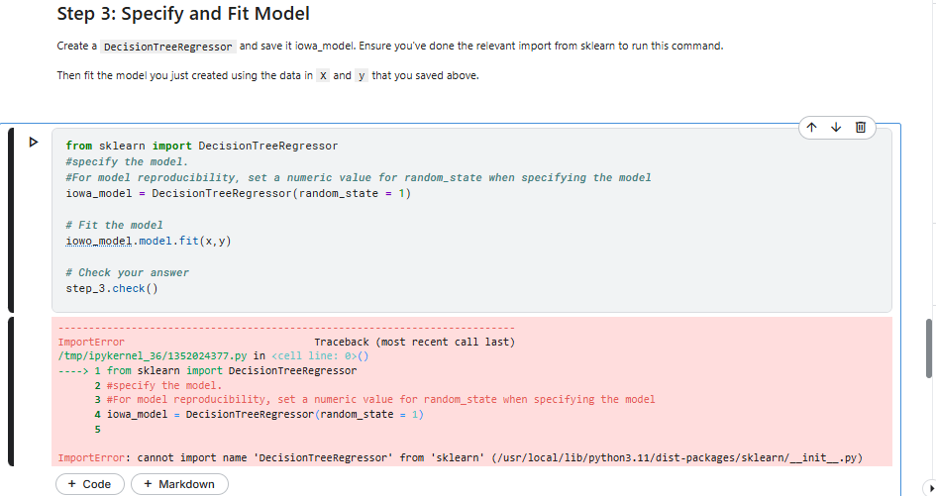
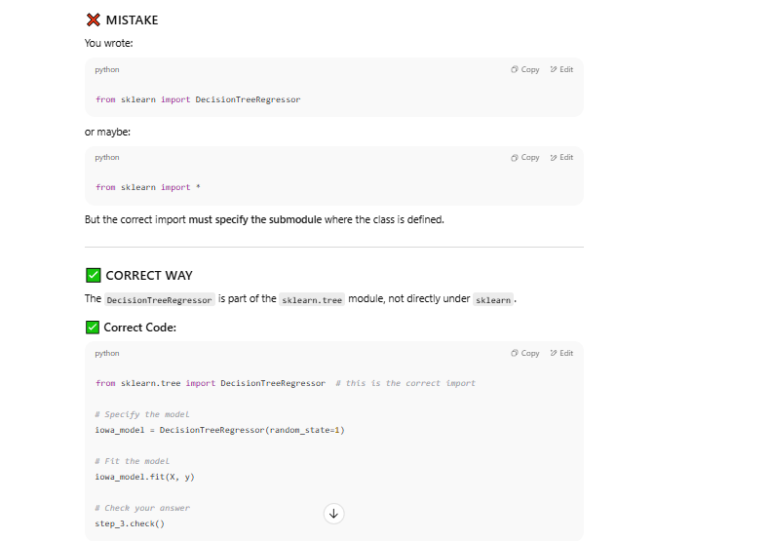
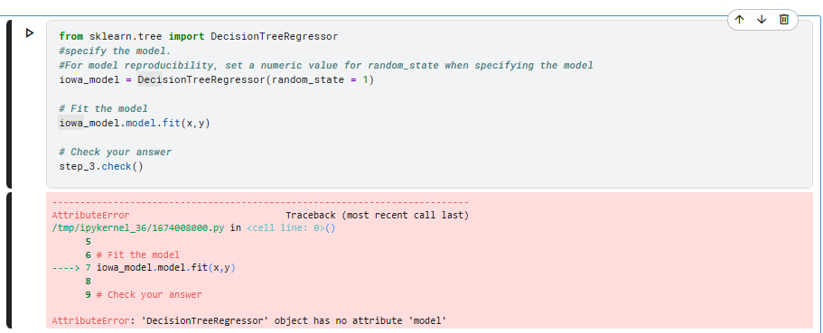
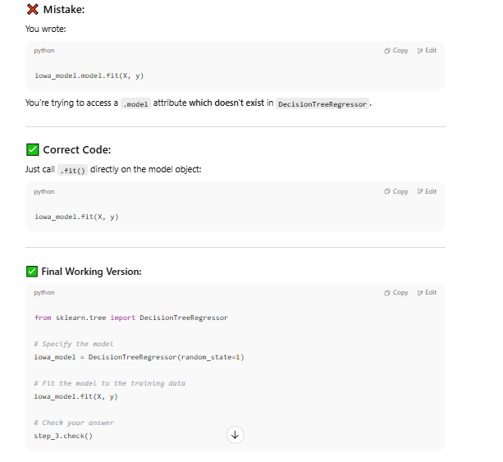

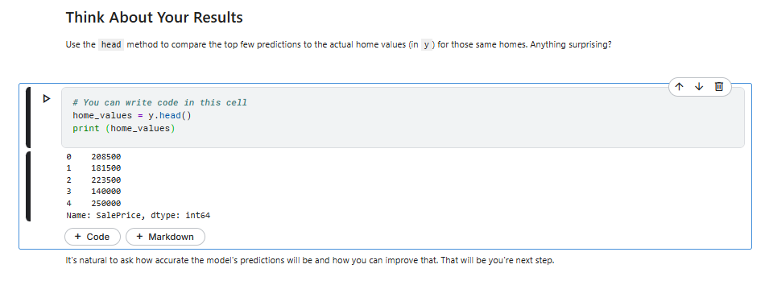
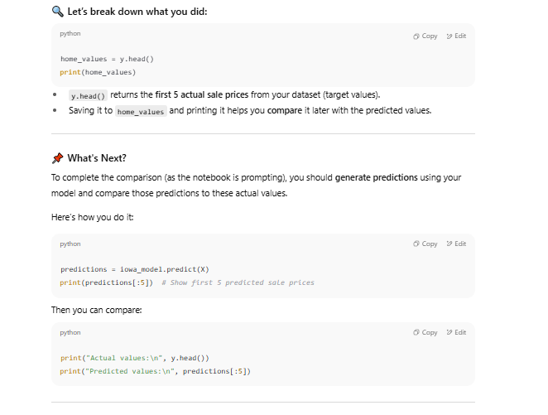

📝 Notes on Model Validation

1. Why Model Validation Matters
- Building a model is only the first step.
- The real question: How well does it perform on new, unseen data?
- Goal: Measure predictive accuracy → how close predictions are to actual outcomes.

2. The Common Mistake
- Beginners often test accuracy using the same data they trained on.
- Problem: Model may learn patterns that only exist in training data (overfitting).
- Example: If training data suggests houses with green doors are expensive, the model will rely on that—even if it’s not true in reality.
This creates in-sample accuracy that looks good but fails on new data.

3. How to Summarize Model Quality
- Comparing thousands of predictions manually is useless.
- Need a single metric.
- One common metric: Mean Absolute Error (MAE).
Formula:
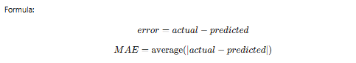
In plain English:
👉 “On average, our predictions are off by about X.”

4. In-Sample Example
- Model trained and tested on the same data:
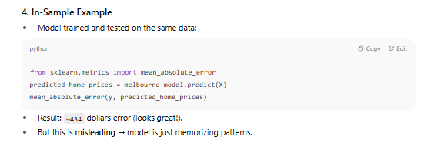
- Result: ~434 dollars error (looks great!).
- But this is misleading → model is just memorizing patterns.

5. The Real Problem
- Models must work on new, unseen data.
- Testing on training data leads to overfitting (too good on training, poor on real-world).
- Solution → split data into:
  - Training set → build model.
  - Validation set → test accuracy on new data.

6. Train-Test Split
- 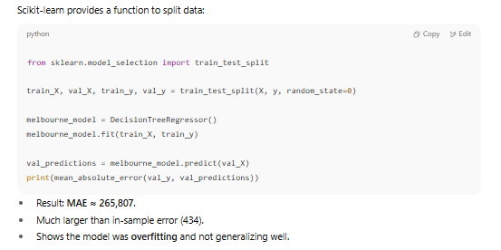Result: MAE ≈ 265,807.
- Much larger than in-sample error (434).
- Shows the model was overfitting and not generalizing well.

7. Key Takeaway
- In-sample scores are misleading.
- Always evaluate on validation data.
- A realistic MAE helps you decide if the model is useful.
- In this case:
  - Training MAE: $500 → nearly perfect (but misleading).
  - Validation MAE: $265,000 → very poor compared to average house price ($1.1M).

8. Next Steps to Improve Model
- Try different features (maybe more informative ones).
- Experiment with different models (e.g., Random Forest).
- Use cross-validation (splitting into multiple train/validation sets).

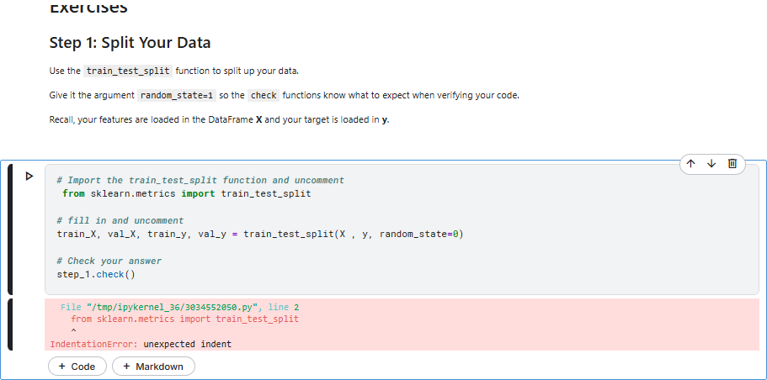
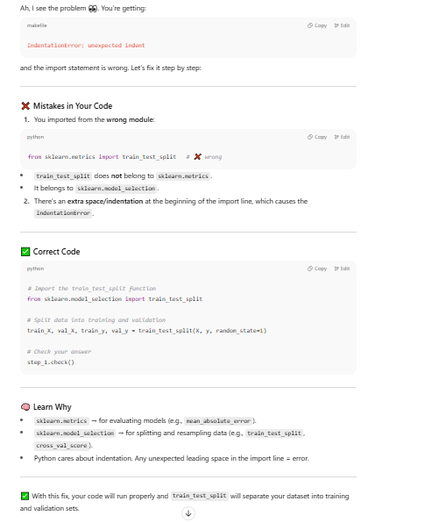

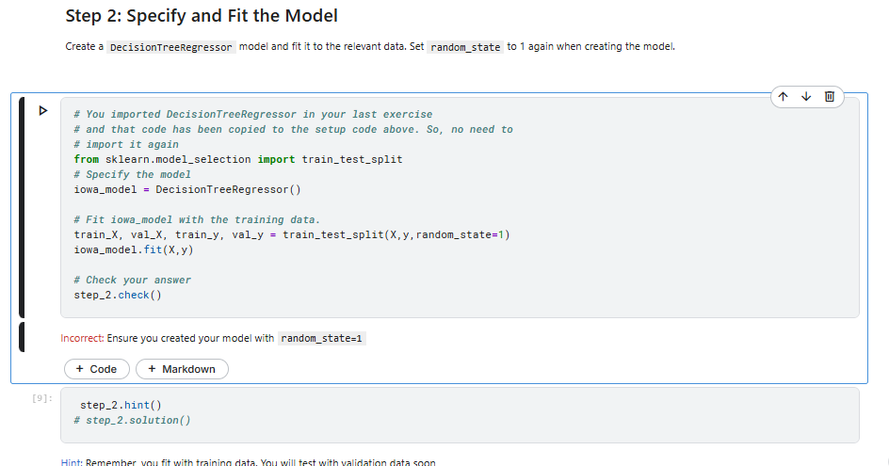

❌ Mistake in Your Code
iowa_model = DecisionTreeRegressor()
- You created the model without specifying random_state=1.
The exercise specifically requires:
iowa_model = DecisionTreeRegressor(random_state=1)
This ensures reproducibility (same results each time you run it).

✅ Correct Code
from sklearn.tree import DecisionTreeRegressor
from sklearn.model_selection import train_test_split

# Split data into training and validation
train_X, val_X, train_y, val_y = train_test_split(X, y, random_state=1)

# Specify the model with random_state=1
iowa_model = DecisionTreeRegressor(random_state=1)

# Fit the model with training data
iowa_model.fit(train_X, train_y)

# Check your answer
step_2.check()

🧠 Key Learning
- Always use random_state=1 (or any fixed number) when splitting data or initializing models in exercises.
- This makes sure your results match the test cases and other learners’ results.
- Without it, you might get slightly different numbers every run → leading to “incorrect” checks.
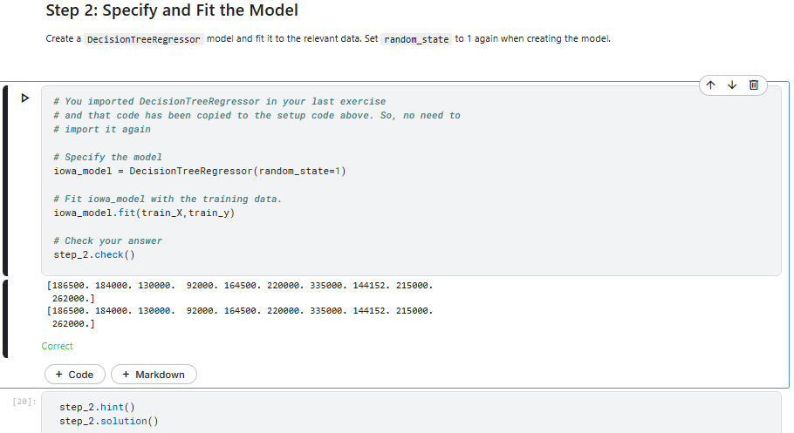
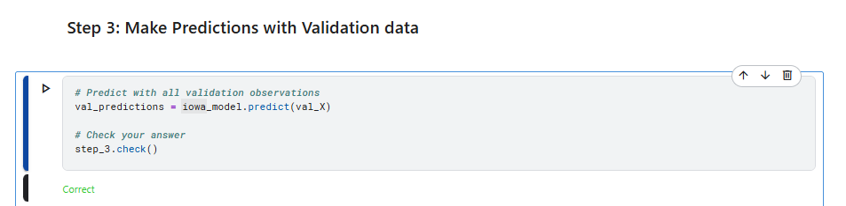
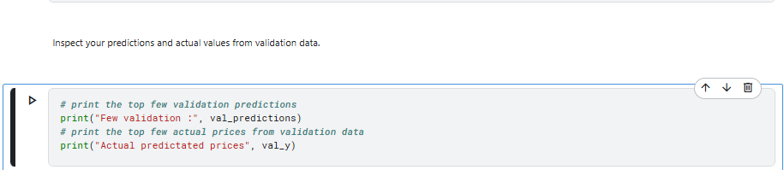
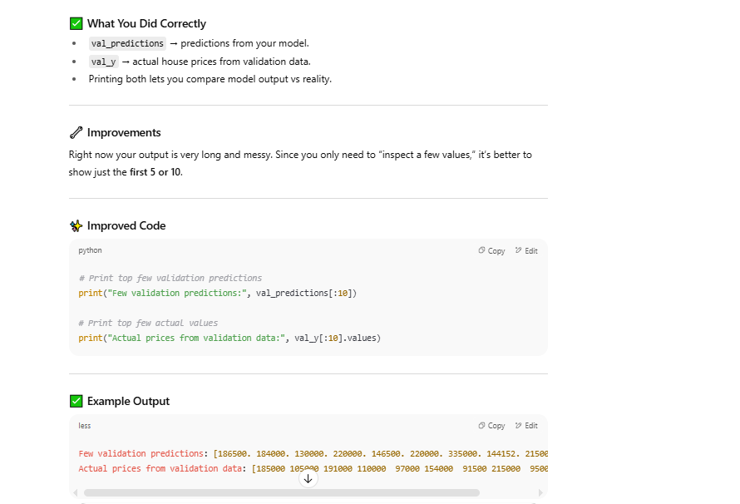
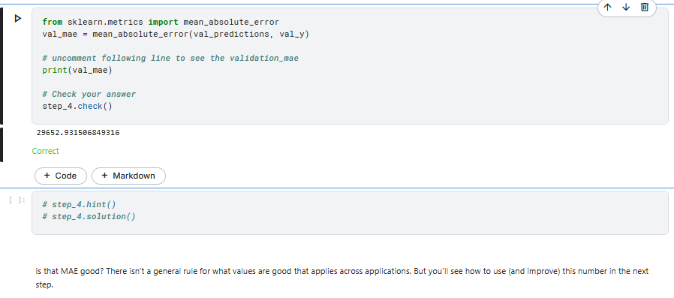

Underfitting and Overfitting

📝 Notes on Underfitting, Overfitting, and Model Optimization

1. Key Concepts
- Underfitting:
  - Model is too simple, fails to capture important patterns.
  - Performs poorly on both training data and validation data.
  - Example: very shallow decision tree (few splits).
- Overfitting:
  - Model is too complex, learns noise and spurious patterns.
  - Performs well on training data, but poorly on validation/new data.
  - Example: very deep tree (too many splits, many small leaves).
- Goal: Find the balance between underfitting and overfitting by tuning model complexity.
  - Use validation data to measure performance on unseen data.
  - Look for the “sweet spot” (lowest validation error).

2. Decision Tree Depth
- Tree depth = how many splits are made before reaching a prediction (leaf).
- Shallow tree: very few leaves → underfitting.
- Deep tree: too many leaves (e.g., 1024 leaves at depth 10) → overfitting.
- Tradeoff: fewer leaves = simpler but less accurate, too many leaves = overly complex.

3. Controlling Complexity
- Use max_leaf_nodes parameter in DecisionTreeRegressor to manage overfitting vs underfitting.
- More leaves → more complexity.
- Fewer leaves → simpler model.

4. Utility Function for MAE
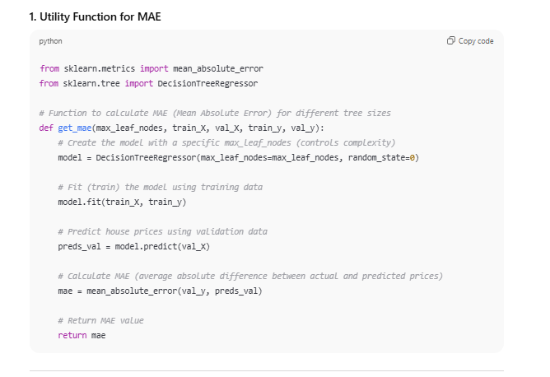
- Fits model with given max_leaf_nodes.
- Predicts on validation set.
- Returns Mean Absolute Error (MAE) as performance metric.

5. Experimentation

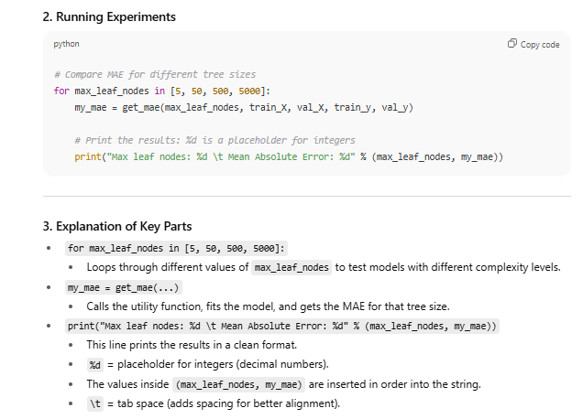Results
- Max leaf nodes: 5 → MAE = 347,380 (underfitting).
- Max leaf nodes: 50 → MAE = 258,171 (improved).
- Max leaf nodes: 500 → MAE = 243,495 (best).
- Max leaf nodes: 5000 → MAE = 254,983 (slight overfitting).
➡️ Optimal complexity in this case = 500 leaves.

6. Conclusion
- Models can fail in two ways:
  - Overfitting: too complex, memorizes training data, poor generalization.
  - Underfitting: too simple, misses patterns, poor accuracy everywhere.
- Solution:
  - Use validation data to test model accuracy.
  - Experiment with parameters (like max_leaf_nodes) to find the balance.
  - Keep the model with the lowest validation error.

✅ Takeaway:
Always check your model on validation data. A perfect fit to training data is misleading—real accuracy is judged on unseen data. Use parameters like max_leaf_nodes to balance underfitting and overfitting.
Exercise
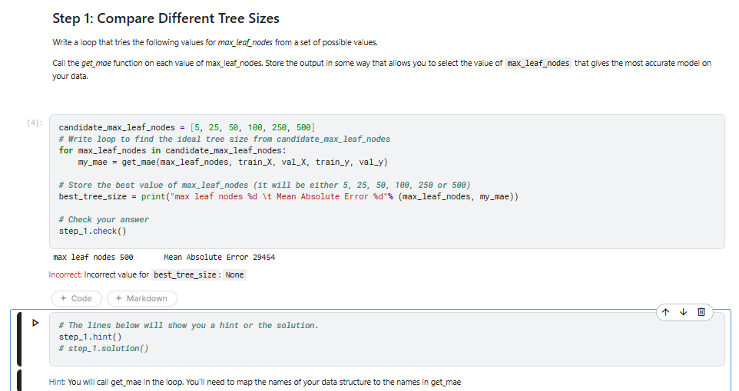
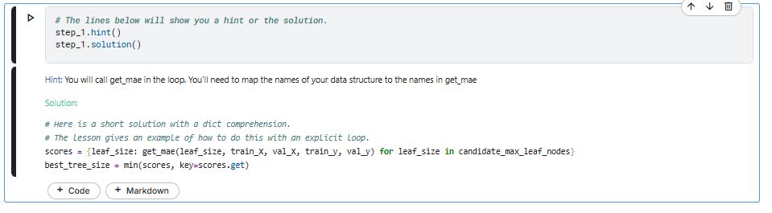
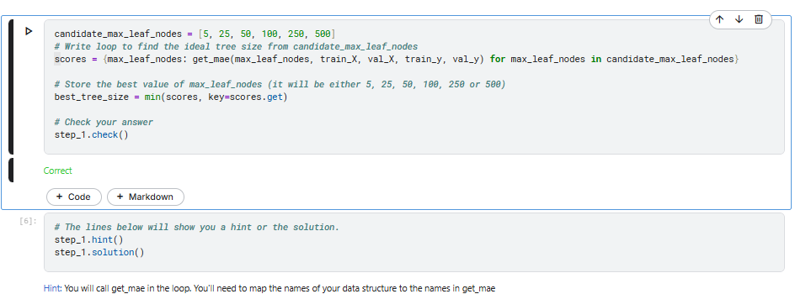

🧠 What the code does (big picture)
You’re searching for the best tree size (model complexity) for a Decision Tree Regressor by:
- trying several candidate values for max_leaf_nodes,
- computing MAE on the validation set for each,
- picking the leaf size with the lowest MAE.

🧩 The code (with roles)
candidate_max_leaf_nodes = [5, 25, 50, 100, 250, 500]

scores = {
max_leaf_nodes: get_mae(max_leaf_nodes, train_X, val_X, train_y, val_y)
for max_leaf_nodes in candidate_max_leaf_nodes
}

best_tree_size = min(scores, key=scores.get)

step_1.check()

1) candidate_max_leaf_nodes — Python list
- What it is: An ordered collection: [item1, item2, ...].
- Here: [5, 25, 50, 100, 250, 500] are integers you’ll test as the tree’s max_leaf_nodes (model complexity).
- Why it matters (ML): Small numbers → simpler tree (risk of underfitting). Large numbers → complex tree (risk of overfitting).

2) scores = { ... for ... } — Dictionary comprehension
- What it is: A compact way to create a dict using a loop in one expression.
- Dictionary: Key–value store: {key: value, ...}.
- Comprehension pattern:
- {key_expr: value_expr for var in iterable}
- Here (unrolled idea):
- scores = {}
- for max_leaf_nodes in candidate_max_leaf_nodes:
- scores[max_leaf_nodes] = get_mae(max_leaf_nodes, train_X, val_X, train_y, val_y)
- Result shape:
- {
- 5: mae_for_5,
- 25: mae_for_25,
- 50: mae_for_50,
- 100: mae_for_100,
- 250: mae_for_250,
- 500: mae_for_500
- }
- Why a dict?
You can easily look up “the MAE for this leaf size” and later ask “which leaf size has the smallest MAE?”

3) get_mae(...) — Function call
- What it is (Python): A function bundles steps and returns a value with return.
- What it does (ML):
  - Builds a DecisionTreeRegressor(max_leaf_nodes=...).
  - Fits it on train_X, train_y.
  - Predicts on val_X.
  - Computes MAE between predictions and val_y.
  - Returns that MAE (a single number).
- Why MAE? Mean Absolute Error = average |actual − predicted|. Lower is better.
(You defined get_mae earlier; this is just invoking it.)

4) min(scores, key=scores.get) — Selecting the best by a criterion
- min(iterable, key=...): Returns the element with the smallest key value.
- Here: The iterable is the dict’s keys (the leaf sizes).
key=scores.get means: for each leaf size, compute the key by calling scores.get(leaf_size) → that’s the MAE.
- Effect: “Give me the leaf size whose MAE is smallest.”
- Return value: The best leaf size (an integer), saved in best_tree_size.
Analogy: You have a scoreboard (dict). min(..., key=...) picks the player (key) with the lowest score (value).

5) step_1.check() — Grader hook
- Provided by the notebook/course. It inspects your variables (like best_tree_size) to mark the exercise Correct or not.

🔬 Python concepts used
- List: ordered, indexable collection → used to hold candidate hyperparameters.
- Dict: key–value mapping → used to map leaf_size → MAE.
- Comprehension: concise looping to build lists/dicts/sets.
- Function: reusable block returning a value (get_mae returns a number).
- Arguments vs. Parameters:
  - Parameters are names in the function definition (max_leaf_nodes, train_X, …).
  - Arguments are the values you pass when calling it.
- min with key: pattern to choose the “best” item by any metric.
- Variable assignment: best_tree_size = ... stores the chosen hyperparameter.

📊 ML concepts used
- Hyperparameter: A setting you choose before training (e.g., max_leaf_nodes).
- Model complexity: More leaves → more complex → can overfit.
- Validation set: Held-out data to estimate performance on unseen data.
- MAE: Lower is better; used to compare models fairly.
- Model selection: Try candidates → evaluate on validation → pick the best.

💡 Optional: nice print for learning/debugging
If you want to see the table of results:
for leaf in candidate_max_leaf_nodes:
mae = scores[leaf]
print(f"leafs={leaf:>4} MAE={mae:,.0f}")
- f"...{leaf:>4}..." → right-align width 4.
- :,.0f → add thousands separators, zero decimals.

✅ Takeaway
- You built a scoreboard dictionary mapping each candidate tree size to its MAE.
- You used min(..., key=...) to extract the argmin (the leaf size with the smallest MAE).
- That value is your best_tree_size—the balanced choice between underfitting and overfitting for this dataset.

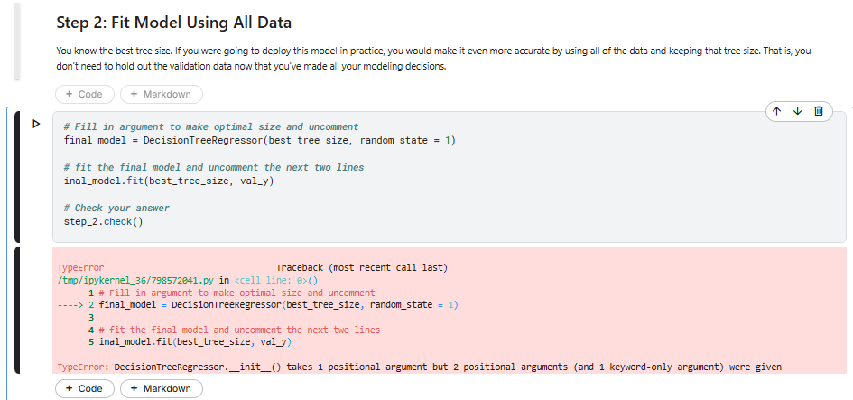
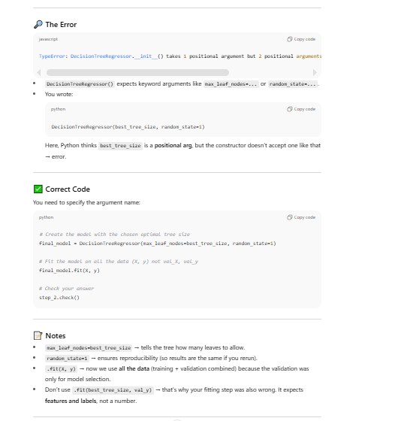

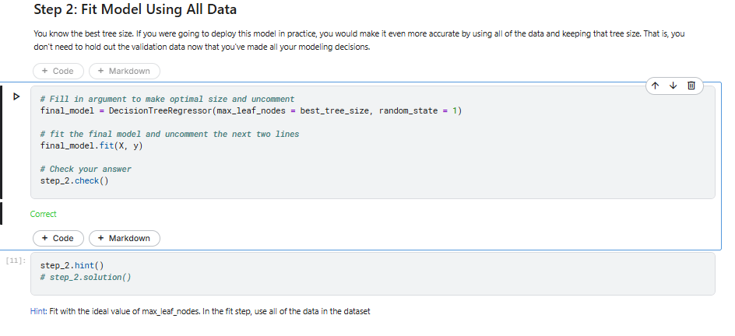

📝 Notes: Fit Model Using All Data

1) The Code
final_model = DecisionTreeRegressor(max_leaf_nodes=best_tree_size, random_state=1)

final_model.fit(X, y)

step_2.check()

2) DecisionTreeRegressor(...)
- This creates a new Decision Tree Regressor model object.
- Important arguments:
  - max_leaf_nodes=best_tree_size
    - Uses the optimal number of leaf nodes you found earlier (e.g., 500).
    - This prevents underfitting (too shallow) or overfitting (too deep).
  - random_state=1
    - Sets the random seed so results are reproducible.
    - Without it, the tree could build slightly differently on each run.
At this point, the model is defined but not trained yet.

3) final_model.fit(X, y)
- .fit() = train the model.
- Inputs:
  - X → your full dataset of features (rooms, bathroom, landsize, etc.).
  - y → target values (house prices).
- What happens under the hood:
  - The decision tree looks at all features.
  - It searches for the best splits to minimize prediction error.
- It keeps splitting until the stopping condition (max_leaf_nodes) is reached.
  - Each leaf node then predicts an average house price for the houses that fall into it.
This is the final training step—now the model knows patterns from the entire dataset.

4) Why Use All Data Here?
- During model selection, we split into train/validation sets to avoid overfitting.
- Now that we’ve chosen the best hyperparameter (best_tree_size), we no longer need to keep data aside.
- Using the full dataset gives the model the most information to learn from.
- This is what you’d do in a real-world deployment.

5) step_2. check()
- This is the course’s built-in grader function.
- It checks if:
- You created the model with the correct max_leaf_nodes=best_tree_size.
  - You trained it on all data (X, y).
- Once correct → it marks the exercise as ✅.

✅ Key Takeaways
- Model definition: DecisionTreeRegressor(max_leaf_nodes=best_tree_size, random_state=1)
- Model training: .fit(X, y) → trained on all data, no validation holdout.
- Best practice: Select hyperparameters with validation data → then retrain final model on all data.
- ML concept: This step maximizes predictive power before deploying the model.

Introduction to Random Forest and Overfitting
Challenge of Decision Trees
- Overfitting vs. Underfitting:
  - Deep Trees (Overfitting): When a decision tree has too many branches (leaves), it becomes overly tailored to the training data and captures noise, leading to poor generalization on new data.
  - Shallow Trees (Underfitting): If the tree is too shallow, it doesn't capture enough patterns from the data, resulting in low predictive accuracy.
Introduction to Random Forest
- Random Forest Approach:
  - A Random Forest is a collection of decision trees used together to improve predictive accuracy.
  - Instead of using a single tree, the model aggregates predictions from many trees, typically improving the accuracy.
  - Random Forest models average the predictions from all the trees, mitigating the risk of overfitting by combining diverse trees.
Key Advantages of Random Forests
- Better Performance: Random Forest generally performs better than a single decision tree, even without parameter tuning.
- Default Parameters: Often works well with default settings, reducing the need for manual parameter adjustments.
- Improvement Potential: There is potential for even greater performance by fine-tuning the model, but the model works sufficiently well as-is.

Example Code Walkthrough
Data Preparation
- Data Loading and Cleaning:
- melbourne_file_path = '../input/melbourne-housing-snapshot/melb_data.csv'
- melbourne_data = pd.read_csv(melbourne_file_path)
- melbourne_data = melbourne_data.dropna(axis=0) # Drop rows with missing values
- Feature Selection:
- Target Variable: y = melbourne_data.Price
- Features: melbourne_features = ['Rooms', 'Bathroom', 'Landsize', 'BuildingArea', 'YearBuilt', 'Lattitude', 'Longtitude']
Train-Test Split
- Data is split into training and validation sets using:
- from sklearn.model_selection import train_test_split
- train_X, val_X, train_y, val_y = train_test_split(X, y, random_state=0)
Random Forest Model
- Building the Model:
- from sklearn.ensemble import RandomForestRegressor
- from sklearn.metrics import mean_absolute_error

- forest_model = RandomForestRegressor(random_state=1)
- forest_model.fit(train_X, train_y) # Fit the model on training data
- melb_preds = forest_model.predict(val_X) # Make predictions on validation set
- print(mean_absolute_error(val_y, melb_preds)) # Output MAE
- Outcome: The model results in an MAE of 191,669.75, showing significant improvement over a simpler decision tree.

Conclusion
- Random Forest’s Strength: Random Forests help avoid overfitting while also addressing the limitations of shallow trees. The use of multiple trees and averaging their predictions leads to better predictive accuracy.
- Room for Improvement: While the Random Forest model has outperformed the decision tree, there's still potential to improve performance by tweaking model parameters or using more advanced techniques.
- Default Parameters: One of the best features of Random Forest is its ability to perform reasonably well even without parameter tuning.
Exercise
